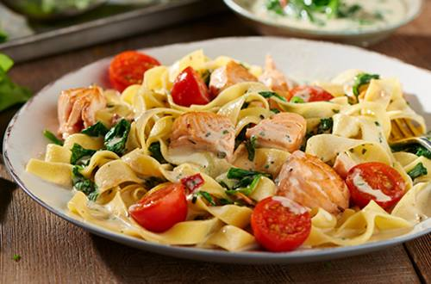

Pasta.

There are many types of pasta.
Spaghetti noodles are long and thin. Lasagna noodles are
wide and flat. Both are delicious with tomato sauce.
Elbow noodles curve in the middle. They are perfect for
making macaroni and cheese.
Stellette pasta looks like little stars. Orzo pasta looks like
rice. Both are yummy in soups.
Pasta comes in all shapes and sizes, and all of it is
delicious!
s

